New Products for 2022

We are delighted to announce three new product ranges for the year ahead: -
Chocolate Covered Nibbles
We have launched a range of 9 dried fruit and nut flavours covered in rich milk or dark chocolate. These are available in both the ever popular hand packed sweet bags, as well as the 225g ribbon bags.

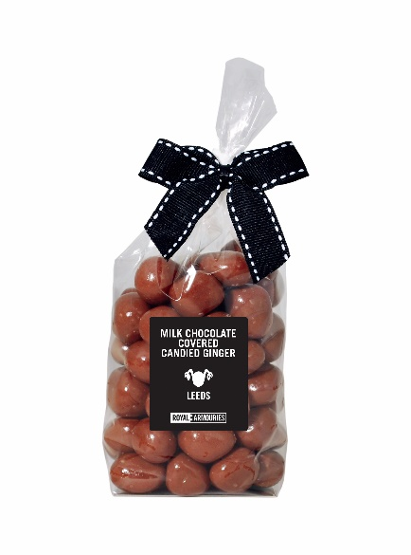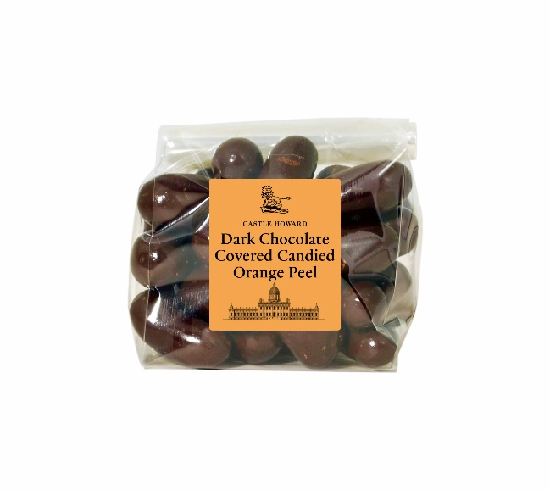
Scented Candles
As a beautiful non-edible gift, we have launched two fresh linen scented candles, one in a lidded glass jar, one in a small drum, both of which can be personalised with your own design.

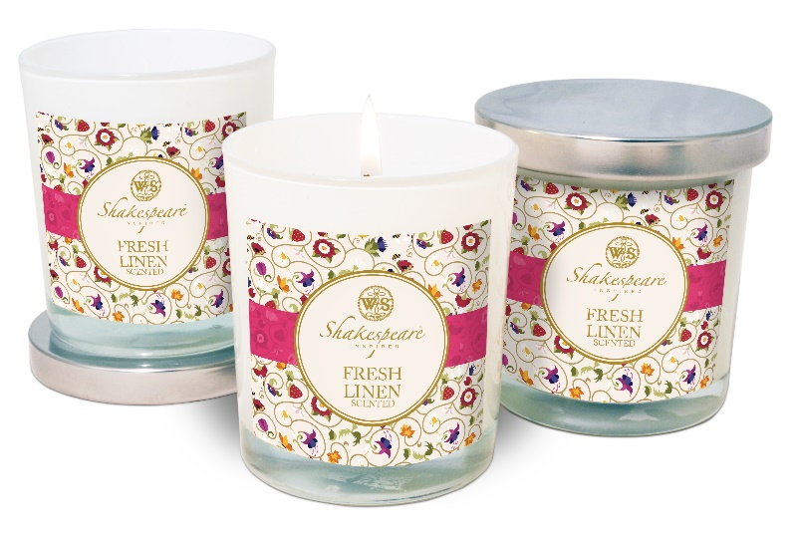

Gift Bags

A new jute bag with a selection of sweets, biscuits, preserves and more, in 8 flavour combinations, all with your own branding, makes an ideal gift .

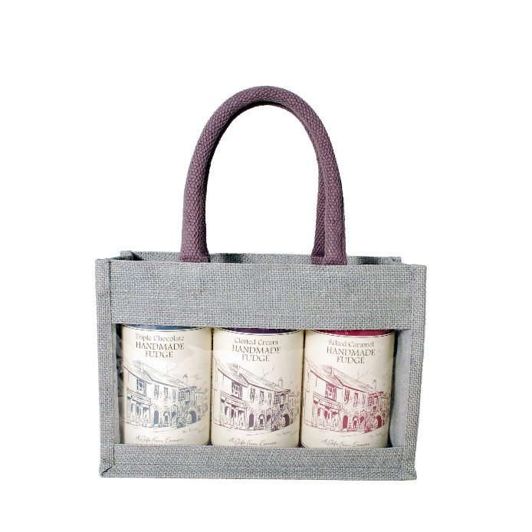

Our minimum order value remains at £250 for 2022, and if you would like any further information please contact us at enquiries@farrahs.com or 01423 88300

